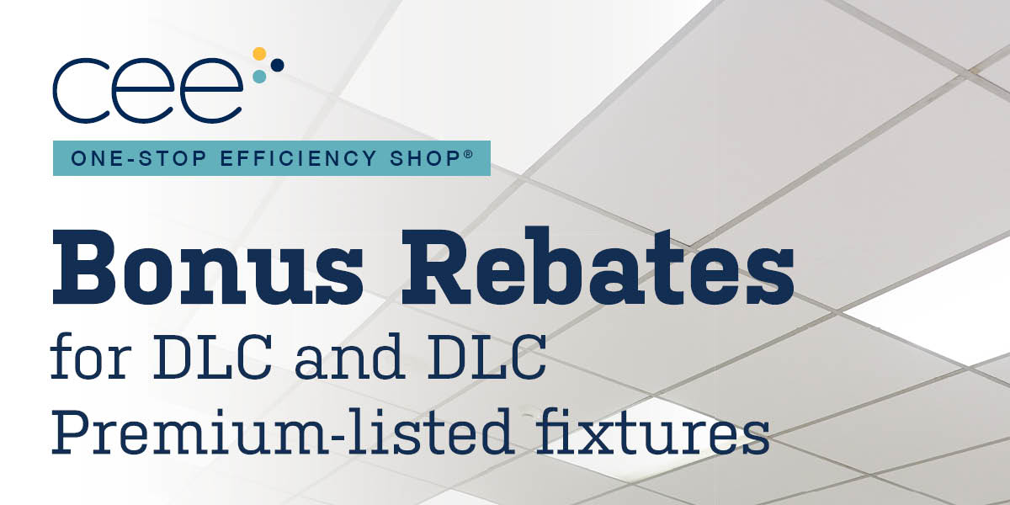
Commercial lighting projects including DLC and DLC premium-listed fixtures and retrofit kits are eligible for an additional 25% in rebates when completed through the One-Stop Efficiency Shop sponsored by Xcel Energy. Don’t miss out on extra savings mncee.org/lighting-bonus

